PART A
(Part A: TO BE REFFERED BY STUDENTS)
Experiment No. 04
A.1 AIM:
Implement basic JavaScript operators, conditional statements, loops etc.
A.2 Pre requisite:
Basic Knowledge of HTML and JavaScript
A.3 Outcome:
After successful completion of this experiment students will be able to:
- Create formatted web pages/websites with attractive look and feel
- Use various JavaScript features
A.4 Theory:
JavaScript is the programming language of the Web. All modern HTML pages are using JavaScript.
JavaScript is one of 3 languages all web developers MUST learn:
- HTML to define the content of web pages
- CSS to specify the layout of web pages
- JavaScript to program the behavior of web pages
JavaScript operators
JavaScript operators are symbols that are used to perform operations on operands.
There are following types of operators in JavaScript.
- Arithmetic Operators
- Comparison (Relational) Operators
- Bitwise Operators
- Logical Operators
- Assignment Operators
- Special Operators
JavaScript Loops
The JavaScript loops are used to iterate the piece of code using for, while, do while or for-in loops. It makes the code compact. It is mostly used in array.
There are three types of loops in JavaScript.
- for loop
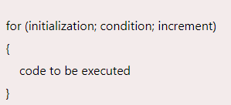

- while loop
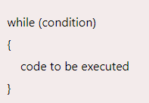
- do-while loop
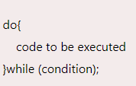

A.5 Procedure/Task:
- Write a JavaScript program to find the area of a triangle where lengths of the three of its sides are 5, 6, 7.
- Write a JavaScript program to compute the sum of the two given integers. If the two values are same, then returns triple their sum.
- Write a JavaScript function that reverse a number.
- Write a JavaScript function that accepts a string as a parameter and converts the first letter of each word of the string in upper case.
- Write a JavaScript conditional statement to find the largest of five numbers. Display an alert box to show the result.
- Write a JavaScript program which compute, the average marks of the following students Then, this average is used to determine the corresponding grade.
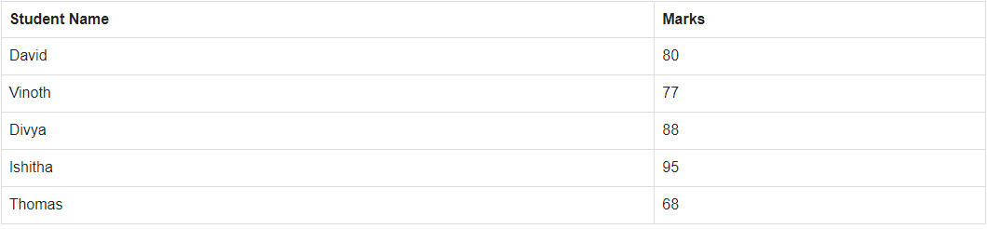
The grades are computed as follows :
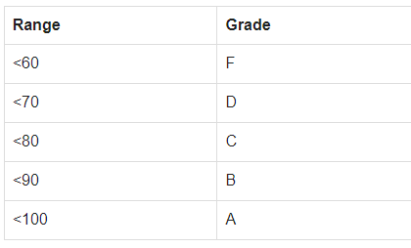
- Write a JavaScript program to construct the following pattern, using a nested for loop.
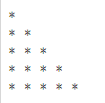
PART B
(PART B: TO BE COMPLETED BY STUDENTS)
(Students must submit the soft copy as per following segments within two hours of the practical. The soft copy must be uploaded on the Blackboard or emailed to the concerned lab in charge faculties at the end of the practical in case the there is no Black board access available)
Roll No. :E009 | Name: Dhrumil Burad
Class : B.tech CSBS | Batch : B1
Date of Experiment : 02-02-2023 | Date/Time of Submission :09-02-2023
Grade :

B.1 Code:
(Paste your Code here)
<!DOCTYPE html>
<html lang="en">

<head>
<meta charset="UTF-8">
<meta http-equiv="X-UA-Compatible" content="IE=edge">
<meta name="viewport" content="width=device-width, initial-scale=1.0">
<title>practical 4 </title>
</head>

<body>
<!-- TASK 1 -->
<article>
<h1>TASK 1</h1>
<h3> JS code to find the area of the triangle </h3>
<br>
Side 1<input type="number" id="s1">
Side 2 <input type="number" id="s2">
Side 3 <input type="number" id="s3">
<button onclick="area()">Submit</button>

<p id="ar">The area of triangle is : </p>
</article>
<br>
<!-- TASK 2 -->
<article>
<H1>TASK 2</H1>
<h3>JavaScript program to compute the sum of the two given integers. If the two values are same, then returns
triple their sum.</h3>
Enter Number 1 <input type="number" id="n1">
Enter Number 2 <input type="number" id="n2">
<button onclick="t2sum()">SUBMIT</button>
<p id="t2res">Result:</p>

</article>

<!-- TASK 3 -->
<article>
<H1>TASK 3</H1>
<h3>JavaScript function that reverse a number. </h3>
Enter the number you want to reverse <input type="number" id="t3n">
<button onclick="reversenum()">SUBMIT</button>
<p id="t3o">Reversed Number is: </p>
</article>

<!-- TASK 4 -->
<article>
<h1>TASK 4</h1>
<h3>JavaScript function that accepts a string as a parameter and converts the first letter of each word of the
string in upper case.</h3>
Enter the string <input type="text" id="t4t">
<button onclick="t4func()">SUBMIT</button>
<p id="t4op">String is :</p>
</article>
<!-- /*TASK 5*/ -->
<article>
<h1>TASK 5</h1>
<h3>Write a JavaScript conditional statement to find the largest of five numbers. Display an alert box to
show the result.</h3>
Enter number 1 <input type="number" id="t51"><br>
Enter number 2 <input type="number" id="t52"><br>
Enter number 3 <input type="number" id="t53"><br>
Enter number 4 <input type="number" id="t54"><br>
Enter number 5 <input type="number" id="t55">
<button onclick="t5func()">Submit</button>
<p id="t5op">Maximum Number is: </p>

</article>
<!-- /*TASK 6*/ -->
<article>
<h1>TASK 6</h1>
<h3>6. Write a JavaScript program which compute, the average marks of students </h3>
Enter marks of student 1 <input type="number" id="t61"><br>
Enter marks of student 2 <input type="number" id="t62"><br>
Enter marks of student 3 <input type="number" id="t63"><br>
Enter marks of student 4 <input type="number" id="t64"><br>
Enter marks of student 5 <input type="number" id="t65">
<button onclick="t6func()">Submit</button>
<p id="t6op">Average of the students is: </p>
<p id="t6op2">Grade of the class is: </p>

</article>
<!-- /*TASK 7*/ -->
<article>
<h1>TASK 7</h1>
<P>7. Write a JavaScript program to construct the following pattern, using a nested for loop.</P>
<button onclick="t7func()">Generate Pattern</button>
<p id="t7op"></p>
</article>
<script>

/*TASK 1*/
function area() {
let x = parseInt(document.getElementById("s1").value)
let y = parseInt(document.getElementById("s2").value)
let z = parseInt(document.getElementById("s3").value)
console.log(x, y, z);

let semip = (x + y + z) / 2;
console.log(semip)
let resar = Math.sqrt(semip * (semip - x) * (semip - y) * (semip - z))
console.log(resar);
document.getElementById('ar').innerHTML += resar
}
/*TASK 2*/
function t2sum() {
let x = parseInt(document.getElementById("n1").value)
let y = parseInt(document.getElementById("n2").value)
console.log(n1, n2)
if (x === y) {
let t2s = 3 * (x + y);
console.log(t2s)
document.getElementById("t2res").innerHTML += "As the numbers are equal output will be 3 times thee sum: " + t2s
}
else {
t2s = x + y;
document.getElementById("t2res").innerHTML += "Sum of 2 integers: " + t2s
}
}

/*TASK 3*/
//method 1
/* function reversenum() {
//let x = parseInt(document.getElementById("t3n"))
let x = document.getElementById("t3n").value
x = x.split("")
let newlist = []
//[i]console.log(x)
for (let i = 0; i <= x.length; i++) {

newlist.push(x.pop())
console.log(newlist)
}
x = newlist.join("");
console.log(x);
document.getElementById("t3o").innerHTML += x
}*/
//method 2
function reversenum() {
let x = document.getElementById("t3n").value
let reversed = 0;
while (x > 0) {
reversed = reversed * 10 + (x % 10);
console.log(reversed)
x = Math.floor(x / 10);
console.log(x)
}
document.getElementById("t3o").innerHTML += reversed
}

/*TASK 4*/
function t4func() {
let x = document.getElementById("t4t").value;
let newar = "";
var i = 0;
for (i = 0; i < x.length; i++) {

if (x[i] == " ") {
newar += x[i];
newar += x[i + 1].toUpperCase();
i = i + 1;
}
else if (i == 0) {
let z = x[i].toUpperCase();
newar += z;
}
else {
newar += x[i];
}
}

document.getElementById("t4op").innerHTML += newar
}
/*TASK 5*/
function t5func() {
let x1 = parseInt(document.getElementById("t51").value);
let x2 = parseInt(document.getElementById("t52").value);
let x3 = parseInt(document.getElementById("t53").value);
let x4 = parseInt(document.getElementById("t54").value);
let x5 = parseInt(document.getElementById("t55").value);
let y = [x1, x2, x3, x4, x5];
let i = 0;
let max = y[0];
console.log(max)
for (i = 0; i < y.length; i++) {
if (max < y[i]) {
max = y[i];
}
}
document.getElementById("t5op").innerHTML += max
}
/*TASK 6*/
function t6func() {
let x1 = parseInt(document.getElementById("t61").value);
let x2 = parseInt(document.getElementById("t62").value);
let x3 = parseInt(document.getElementById("t63").value);
let x4 = parseInt(document.getElementById("t64").value);
let x5 = parseInt(document.getElementById("t65").value);
let avg = (x1 + x2 + x3 + x4 + x5) / 5
console.log(avg)
if (avg < 60) {
document.getElementById("t6op2").innerHTML += "F"
}
else if (60 < avg < 70) {
document.getElementById("t6op2").innerHTML += "D"
}
else if (70 < avg < 80) {
document.getElementById("t6op2").innerHTML += "C"
}
else if (80 < avg < 90) {
document.getElementById("t6op2").innerHTML += "B"
}
else {
document.getElementById("t6op2").innerHTML += "A"
}
document.getElementById("t6op").innerHTML += avg
}
/*TASK 7*/
function t7func() {
for (i = 0; i <= 5; i++) {
for (j = 0; j < i; j++) {
document.getElementById("t7op").innerHTML += "* "
}
document.getElementById("t7op").innerHTML += "<br>"
}
}
</script>
</body>

</html>

B.2 Output
(Take screen shots of the output at run time and paste it here)
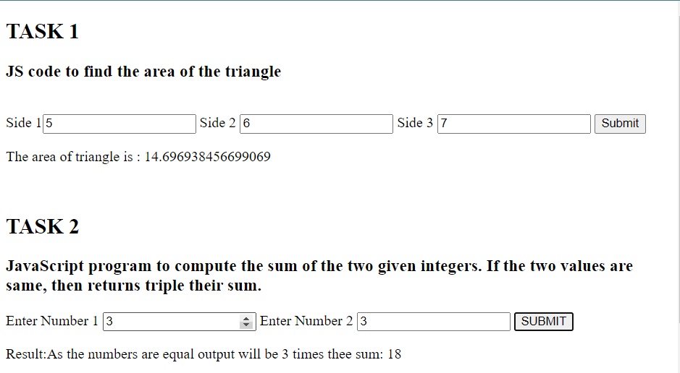
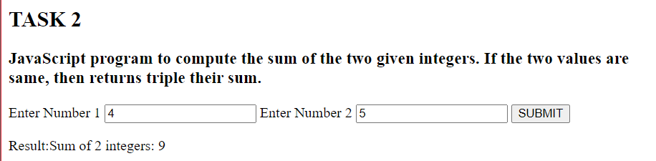
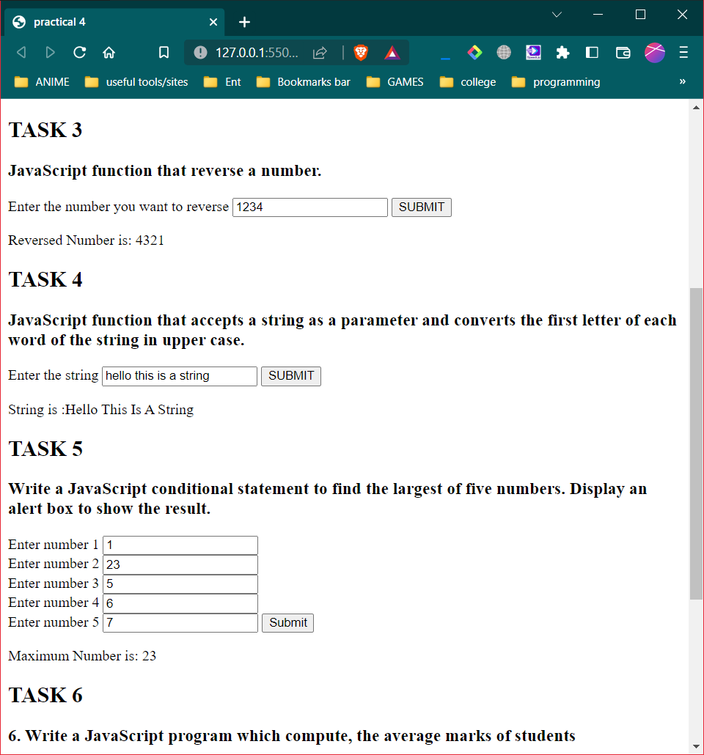
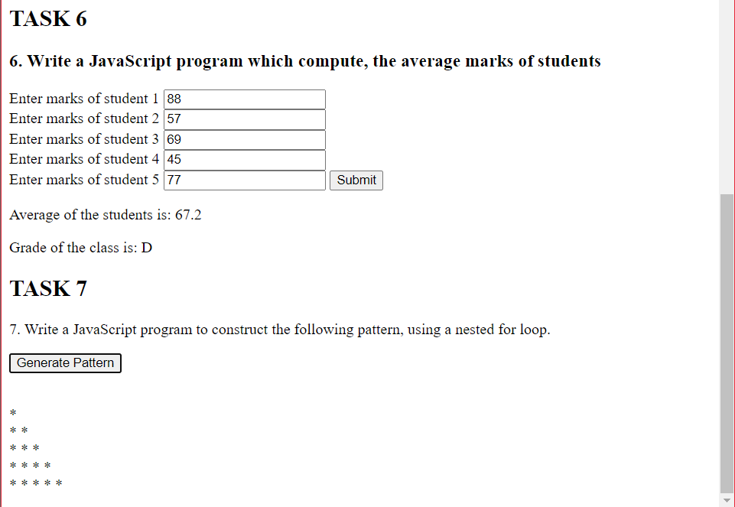
B.3 Conclusion:
(Students must write the conclusion as per the attainment of individual outcome listed above)
Implemented JavaScript to perform various tasks

B.3 Observations and Learning:
(Students must write their observations and learnings as per the attainment of individual outcome listed above)
Learnt about JavaScript and how to use JS to make a webpage interactive and how to perform various functions taking user input. Learnt about retrieving a value given by user and computing the value to give a desired output to the user.

